**Week 5:**

**React Hands On:**

**1.React JS HOL:**

[**App.js**](http://app.js)**:**

**import React, { useState } from 'react';**

**function App() {**

**const [count, setCount] = useState(0);**

**return (**

**<div style={{ textAlign: 'center', marginTop: '50px' }}>**

**<h1>Counter App</h1>**

**<p>Count: {count}</p>**

**<button onClick={() => setCount(count + 1)}>Increment</button>**

**<button onClick={() => setCount(count - 1)}>Decrement</button>**

**<button onClick={() => setCount(0)}>Reset</button>**

**</div>**

**);**

**}**

**export default App;**

**Output:**

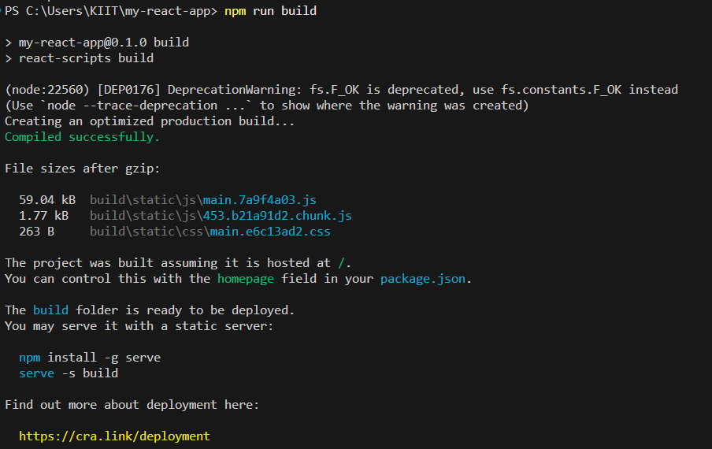

**2.React JS HOL:**

[**Home.js**](http://home.js)**:**

**// Home.js**

**import React from 'react';**

**function Home() {**

**return (**

**<div>**

**<h2>Welcome to the Home page of Student Management Portal</h2>**

**</div>**

**);**

**}**

**export default Home;**

[**About.js**](http://about.js)**:**

**// About.js**

**import React from 'react';**

**function About() {**

**return (**

**<div>**

**<h2>Welcome to the About page of Student Management Portal</h2>**

**</div>**

**);**

**}**

**export default About;**

[**Contact.js**](http://contact.js)**:**

**// Contact.js**

**import React from 'react';**

**function Contact() {**

**return (**

**<div>**

**<h2>Welcome to the Contact page of Student Management Portal</h2>**

**</div>**

**);**

**}**

**export default Contact;**

[**App.js**](http://app.js)**:**

**// App.js**

**import React from 'react';**

**import Home from './Components/Home';**

**import About from './Components/About';**

**import Contact from './Components/Contact';**

**function App() {**

**return (**

**<div>**

**<Home />**

**<About />**

**<Contact />**

**</div>**

**);**

**}**

**export default App;**

**Output:**

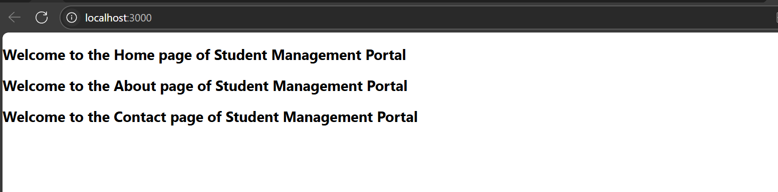

**3.React JS HOL:**

[**Greet.js**](http://greet.js)**:**

**import React from 'react';**

**const Greet = (props) => {**

**return <h1 style={{ color: 'blue' }}>Hello, {props.name}! (Function Component)</h1>;**

**};**

**export default Greet;**

[**Welcome.js**](http://welcome.js)**:**

**import React, { Component } from 'react';**

**class Welcome extends Component {**

**render() {**

**return <h1 style={{ color: 'green' }}>Welcome, {this.props.name}! (Class Component)</h1>;**

**}**

**}**

**export default Welcome;**

[**App.js**](http://app.js)

**import React from 'react';**

**import Greet from './Greet';**

**import Welcome from './Welcome';**

**function App() {**

**return (**

**<div>**

**<Greet name="Alice" />**

**<Welcome name="Bob" />**

**</div>**

**);**

**}**

**export default App;**

**Output:**

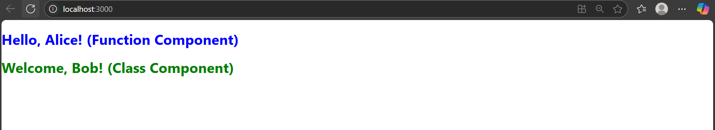

**4.ReactJS HOL:**

[**Posts.js**](http://posts.js)**:**

**import React, { Component } from 'react';**

**class Posts extends Component {**

**constructor(props) {**

**super(props);**

**this.state = {**

**posts: []**

**};**

**console.log('1. Constructor: Component is constructed');**

**}**

**componentDidMount() {**

**console.log('3. componentDidMount: Component is mounted to DOM');**

**// Simulate loading posts from an API**

**setTimeout(() => {**

**this.setState({**

**posts: ['Post 1', 'Post 2', 'Post 3']**

**});**

**}, 1000);**

**}**

**componentDidUpdate(prevProps, prevState) {**

**console.log('4. componentDidUpdate: State or props changed');**

**}**

**componentWillUnmount() {**

**console.log('5. componentWillUnmount: Component is about to be removed');**

**}**

**render() {**

**console.log('2. Render: Component is rendering');**

**return (**

**<div style={{ padding: '20px', backgroundColor: '#f0f0f0', borderRadius: '8px' }}>**

**<h2>Latest Posts</h2>**

**<ul>**

**{this.state.posts.map((post, index) => (**

**<li key={index}>{post}</li>**

**))}**

**</ul>**

**</div>**

**);**

**}**

**}**

**export default Posts;**

[**App.js**](http://app.js)**:**

**import React from 'react';**

**import Posts from './Posts';**

**function App() {**

**return (**

**<div style={{ padding: '20px' }}>**

**<h1>My Blog App</h1>**

**<Posts />**

**</div>**

**);**

**}**

**export default App;**

**Output:**

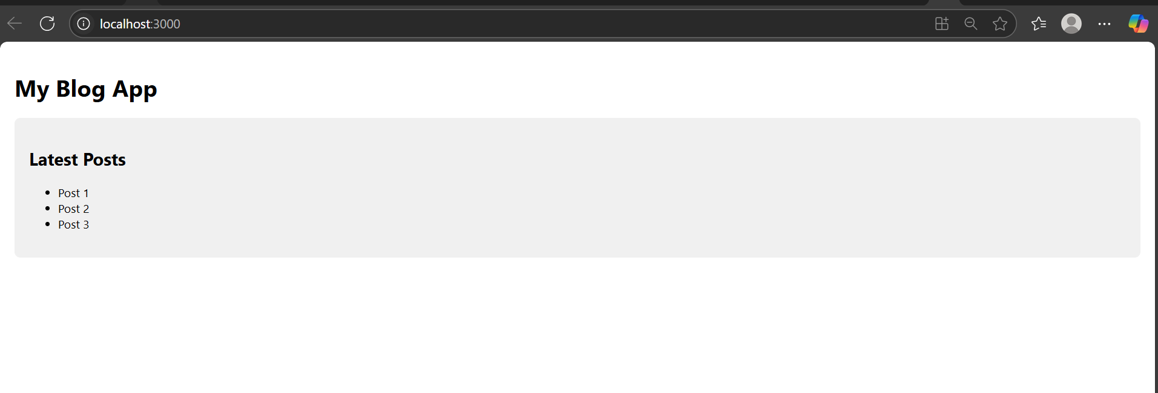

**5. ReactJS HOL:**

[**CohortDashboard.js**](http://cohortdashboard.js)**:**

**import React from 'react';**

**import styles from './CohortDashboard.module.css'; // Import CSS Module**

**function CohortDashboard() {**

**return (**

**<div className={styles.dashboard}>**

**<dl>**

**<dt className={styles.cohortTitle} style={{ color: '#2c3e50' }}>Ongoing Cohorts</dt>**

**<dd>Full Stack Development (Jan 2024)</dd>**

**<dd>DevOps (Mar 2024)</dd>**

**<dt className={styles.cohortTitle} style={{ color: '#e74c3c', fontStyle: 'italic' }}>Completed Cohorts</dt>**

**<dd>Python Essentials (Dec 2023)</dd>**

**<dd>Java Advanced (Nov 2023)</dd>**

**</dl>**

**</div>**

**);**

**}**

**export default CohortDashboard;**

**CohortDashboard.module.css:**

**.dashboard {**

**background-color: #f8f9fa;**

**padding: 1.5rem;**

**border-radius: 8px;**

**margin: 1rem;**

**}**

**.cohortTitle {**

**font-weight: 500; /* Set font weight as required */**

**margin-top: 1rem;**

**margin-bottom: 0.5rem;**

**border-bottom: 1px solid #ddd;**

**padding-bottom: 0.25rem;**

**}**

**/* Style <dt> tag globally (tag selector, as required) */**

**dt {**

**font-weight: 500;**

**}**

[**App.js**](http://app.js)**:**

**import React from 'react';**

**import CohortDashboard from './CohortDashboard';**

**function App() {**

**return (**

**<div style={{ maxWidth: '600px', margin: '0 auto' }}>**

**<h1 style={{ color: '#3498db', textAlign: 'center' }}>**

**My Academy Dashboard**

**</h1>**

**<CohortDashboard />**

**</div>**

**);**

**}**

**export default App;**

**Output:**

